

Dr. Steven, Mcfarland inc.
2016-06-22
Dr. Mcfarland
17876 Kristin Well Apt. 642, Marvinburgh, GU 74760
Phone: 8209012088
Fax: 1086873308

Re: Erica, Daugherty
PHN: 4851284671
Birthdate: 25-Jul-2001
Address: 59275 John Shores, Nicolechester, MI 65758
Patient number: 6805710119

To Whom It May Concern:

This is a medical letter to state the above patient is pregnant with expected delivery date of 04-Mar-2025. Hoping this information is satisfactory for your requirements.

Thank you.

Sincerely,
Dr. Steven, Mcfarland
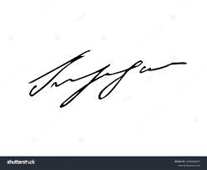
FRCS© NCMP
Clinical Assistant Professor, UBC
Department of Obstetrics and Gynecology SMH

